Performance testing

**Utils**:

* Jmeter – Gui only to prepare the tests. Executing the tests by CLI Mode.
* burp suite – The usable tool for intercepting requests.

Spis treści

1. Book a fllight scenario: 2

1. Performance testing – testy wydajnosciowe. 2

1. Test case 1 2

2. Test case 2 3

2. Stability testing – testy stabilności. 4

3. Test case 1 4

4. Test case 2 5

3. Load testing - Testy obciążeniowe. 6

5. Test case 1 – steady increase traffic on the website. 6

6. Test case 2 – sudden increase number of users. 7

# Book a fllight scenario:

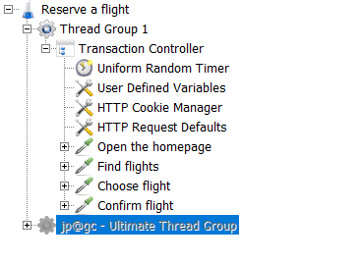

**Website URL:** [https://blazedemo.com](https://blazedemo.com/)

## Performance testing – testy wydajnosciowe.

### Test case 1

**Thread group:** 50

**Duration**: 600 seconds

**Ramp up-period**: 6 seconds.

**Loop count:** infinite

**Think time:** 3000-7000 ms.

**Results:**

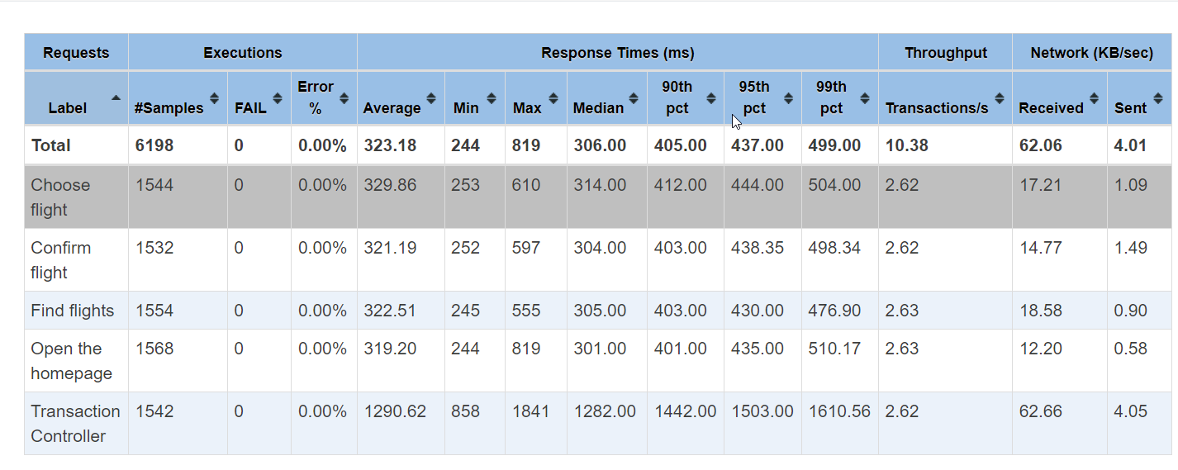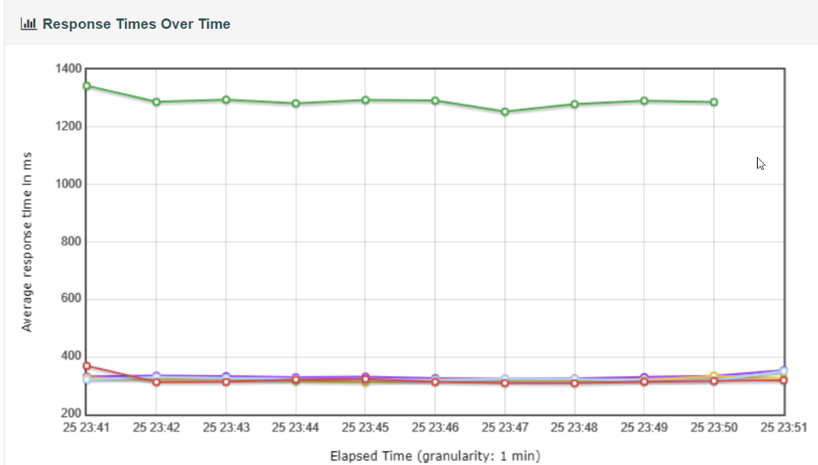

### Test case 2

**Thread group:** 100

**Duration**: 10 minutes.

**Ramp up-period**: 6 seconds.

**Loop count:** infinite

**Think time:** 3000-7000 ms.

**Results:**

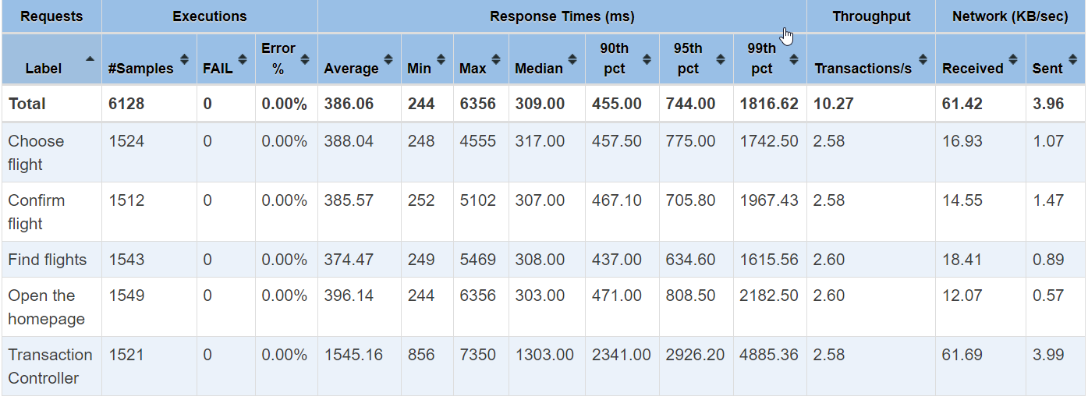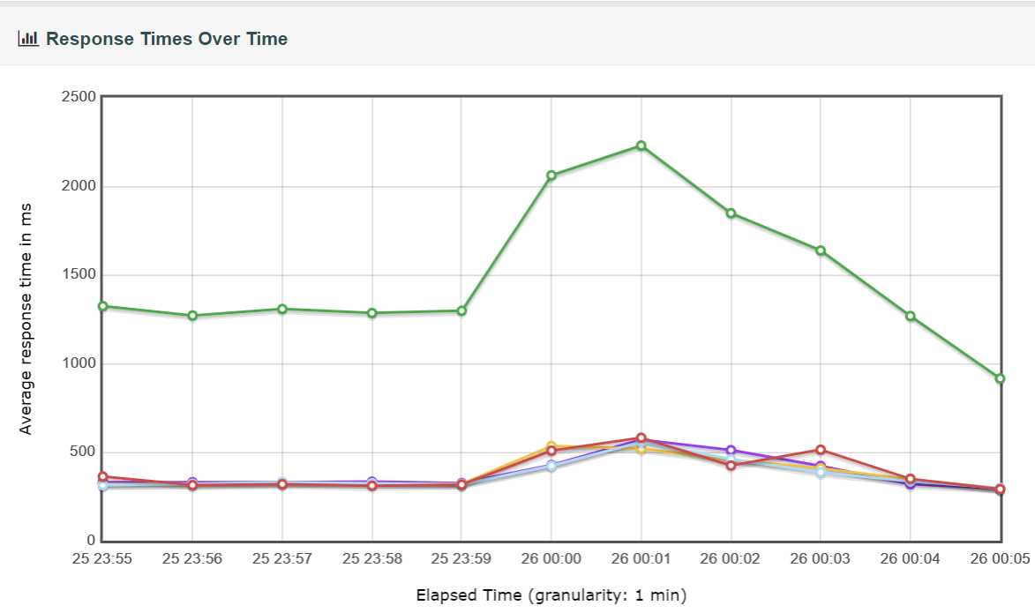

## Stability testing – testy stabilności.

### Test case 1

**Thread group:** 50

**Duration**: 1 hour.

**Ramp up-period**: 60 seconds.

**Loop count:** infinite

**Think time:** 3000-7000 ms.

**Results:**

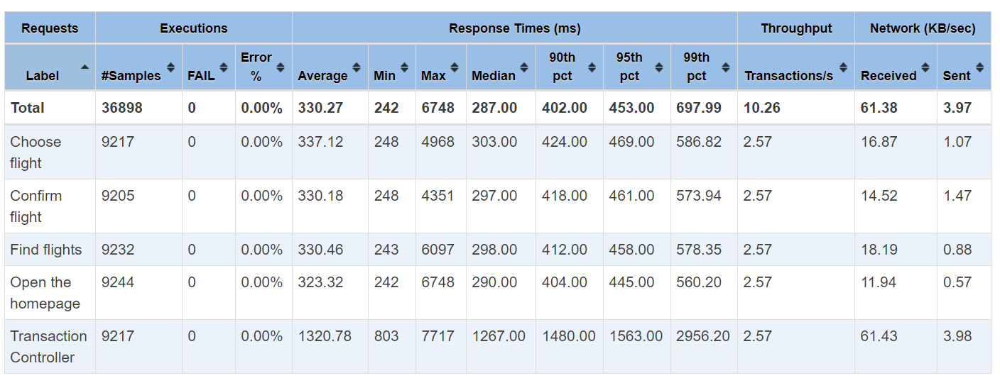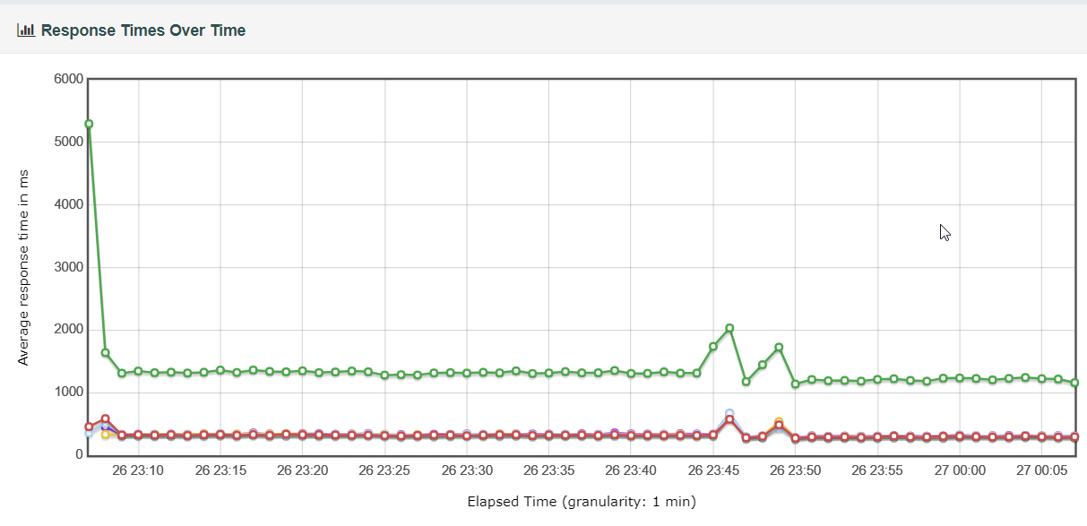

### Test case 2

**Thread group:** 100

**Duration**: 1 hour.

**Ramp up-period**: 60 seconds.

**Loop count:** infinite

**Think time:** 3000-7000 ms.

**Results:**

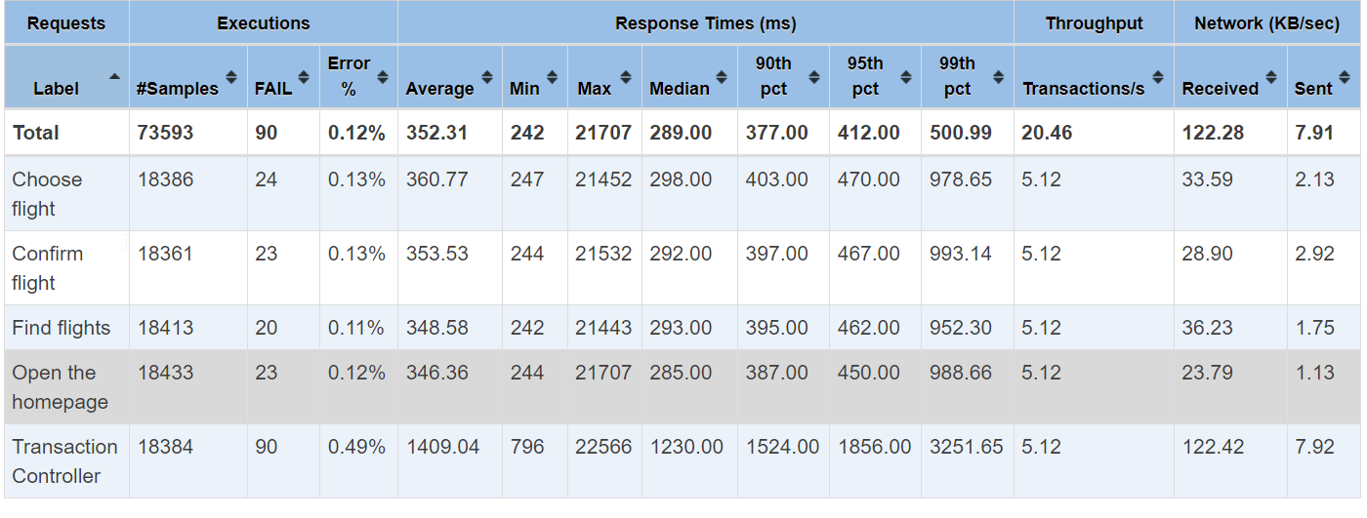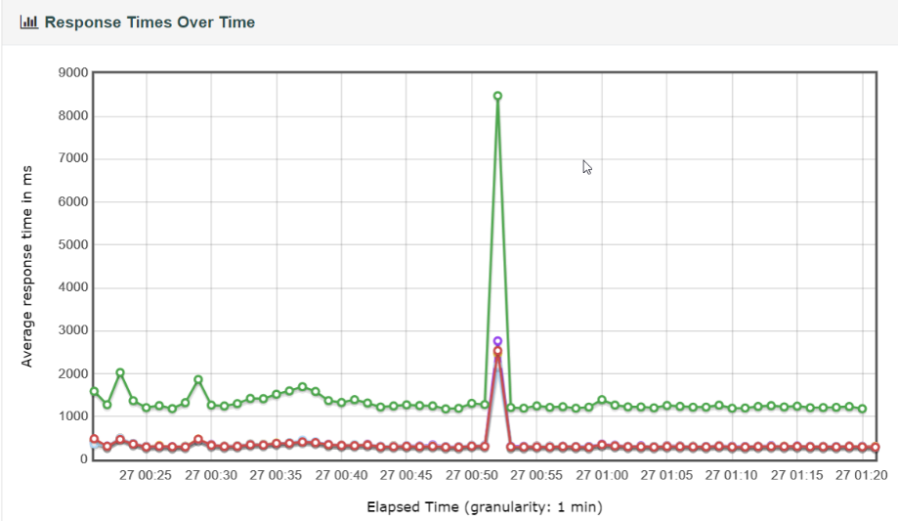

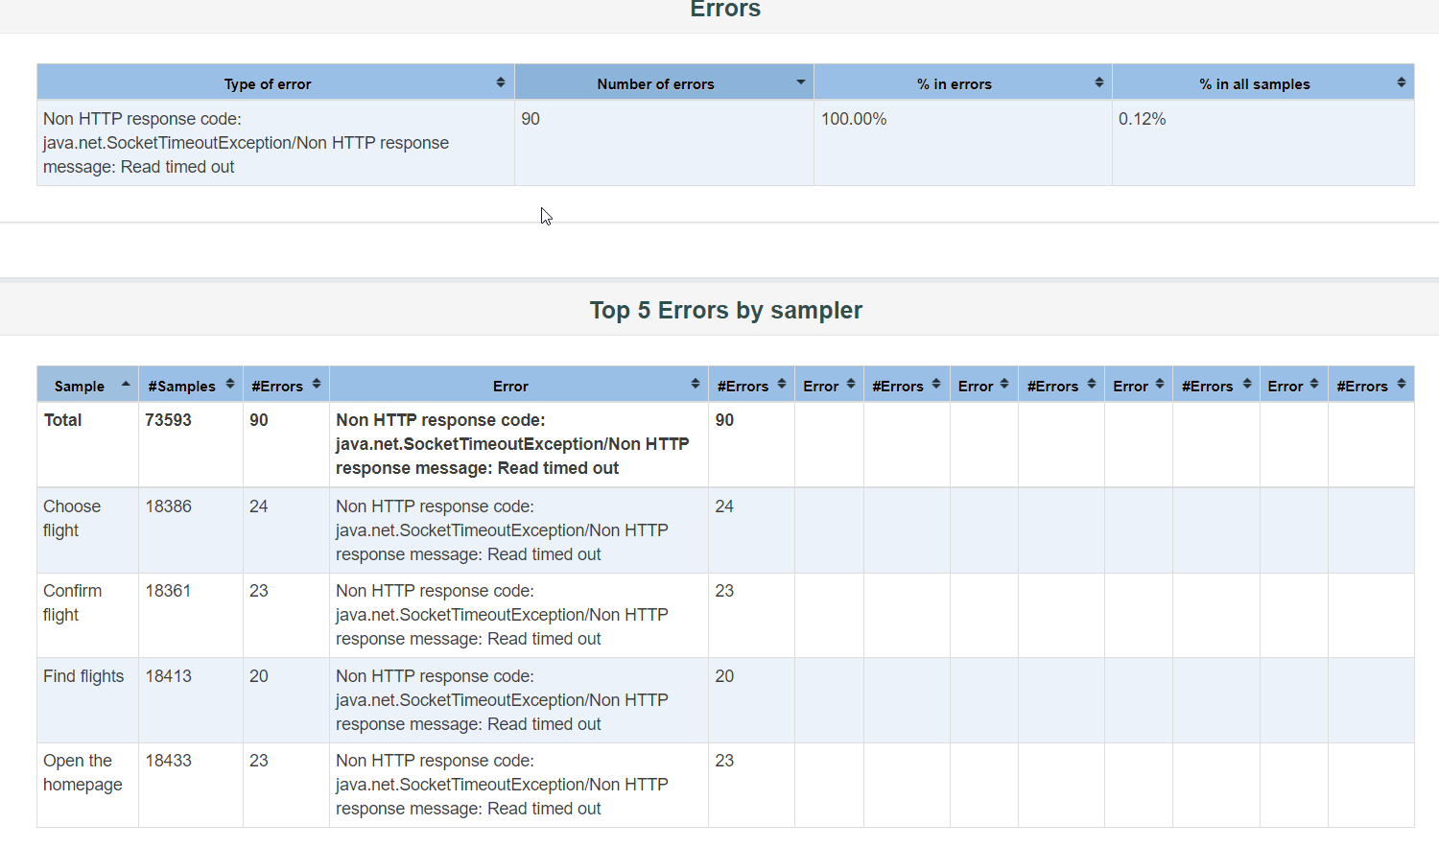

## Load testing - Testy obciążeniowe.

Requirements:

* Install **ultimate thread group**

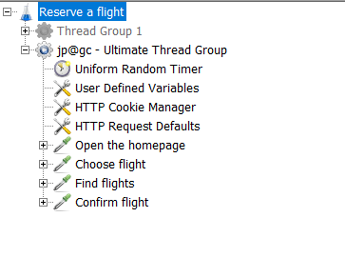

### Test case 1 – steady increase traffic on the website.

**Thread group:** 0-100

**Duration**: 600s.

**Ramp up-period**: 600s.

**Loop count:** infinite

**Think time:** 3000-7000 ms.

**Results:**

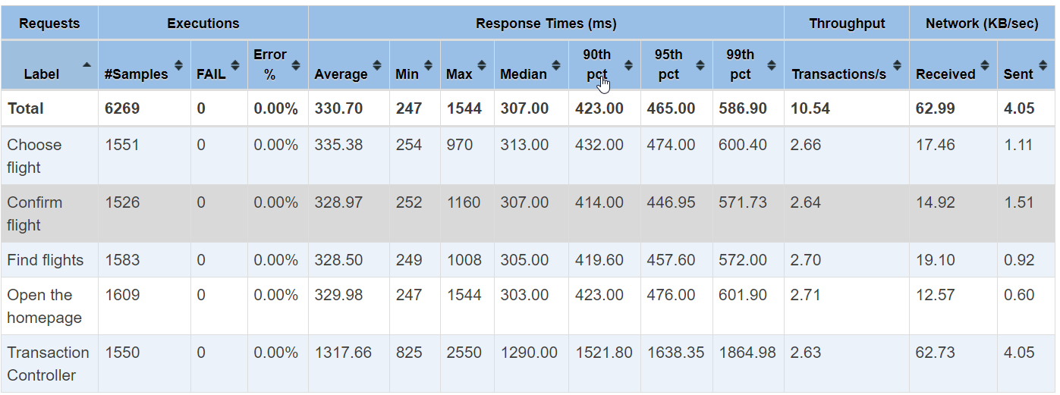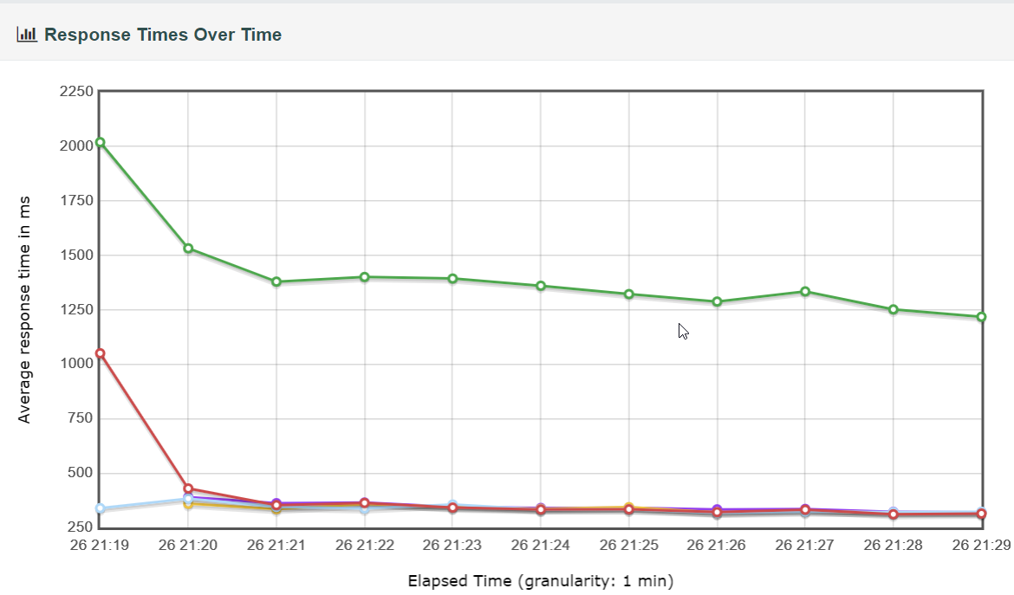

### Test case 2 – sudden increase number of users.

**Thread group:** 20-120

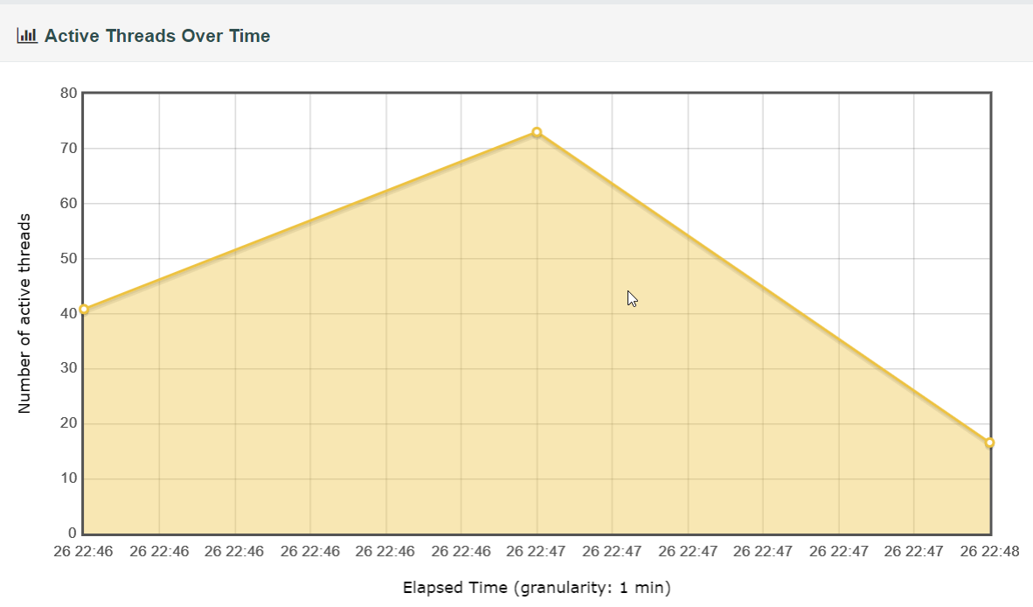

**Duration**: around 120s.

**Ramp up-period**: none.

**Loop count:** infinite

**Think time:** 3000-7000 ms.

**Results:**

